HP ProLiant Gen8 Servers - How to Generate an Advanced Survey Report

Information
HP Advanced Survey report captures all the information about installed hardware. It captures information such as server model, serial number, Memory spare part numbers, Power supply status, Fans, HDDs, PCI devices, Temperature reading, NICs etc.
NOTE: When the survey report is generated, it is not testing the hardware on any hardware components; rather it is capturing the status of the hardware components.
This report is very helpful when user troubleshoot hardware related issues of user's server.
In the case of HP ProLiant G7 and below series servers, user was using HP SmartStart CD to boot the server and generate this survey report. As HP Gen8 server does not use SmartStart CDs anymore, the method to generate survey report is slightly different. First, users have to launch HP Intelligent Provisioning and then open HP Insight Diagnostics to generate HP Advanced Survey report on Gen8 Servers.

Details
How to generate Advanced Survey report on HP ProLiant Gen8 Servers:
- Turn ON the server.
- Once HP Logo screen is shown, press F10 key to launch Intelligent Provisioning :
- 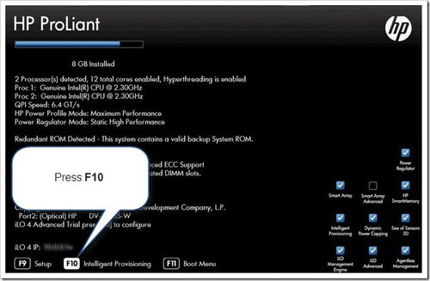
- HP Intelligent provisioning will load on the user's server.
- Click on Perform Maintenance option from Intelligent provisioning :
- 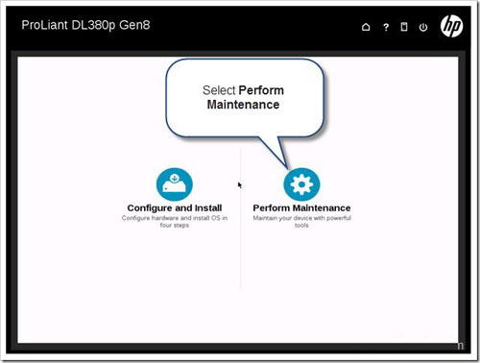
- Now, user may find a lot of utilities listed in Intelligent provisioning window.
- Open Insight Diagnostics from this screen:
- 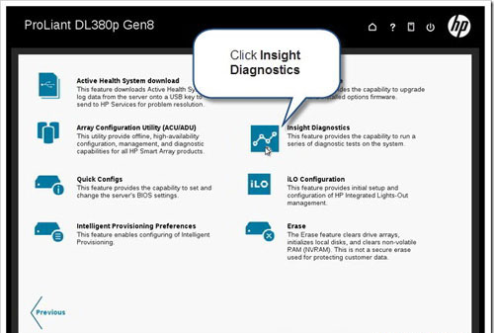
- Please wait while HP Insight Diagnostics loads on the server:
- 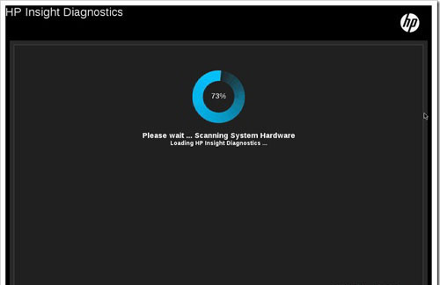
- Once it finishes loading, the screen will look like image provided below:
- 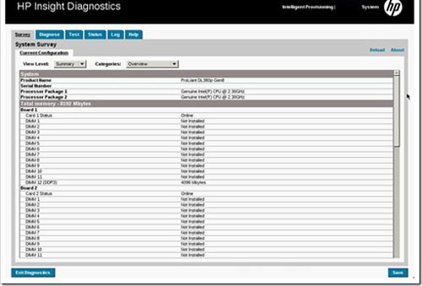
- To generate report, change View level to Advanced :
- 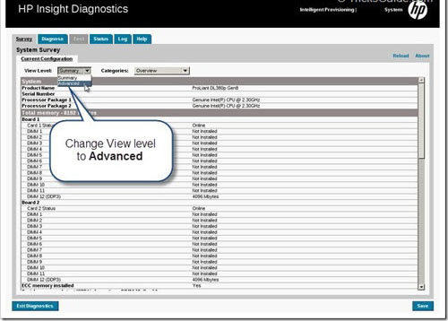
- Then change Categories to All :
- 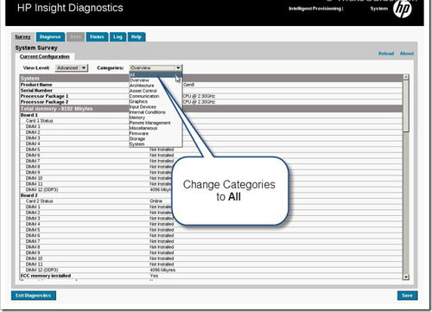
- NOTE: If the user is accessing the server from remote location, then user can make use of Virtual media feature of iLO. First, connect a USB key to the computer and then launch iLO of the Gen8 Server from the same computer.
- From iLO, launch Remote Console , click Virtual Drives , then select Floppy/USB key and select the drive letter of the USB key connected.
- 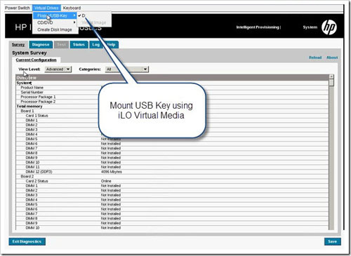
- Click Save button to save the report to a USB key locally connected to the server.
- Select Save Entire Survey and click OK :
- 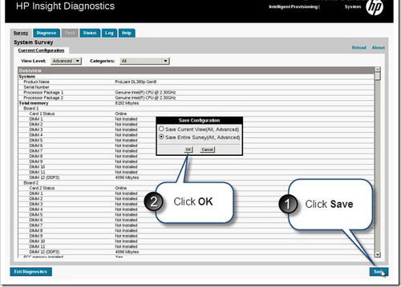
- Click Save button again:
- 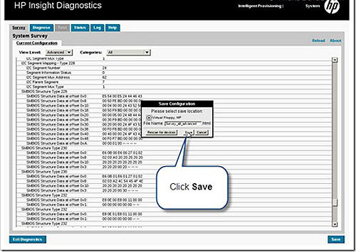
- User will receive a confirmation message as shown below:
- 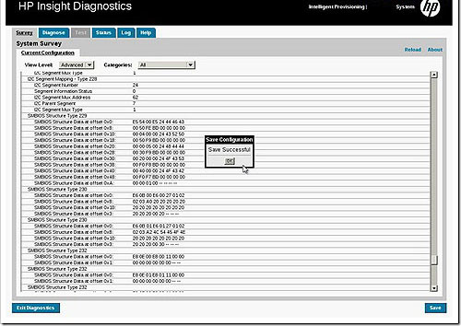
- Gen8 Server survey report has been successfully generated.

-----Original Message-----
From: Gorchenko, Aleksandr [mailto:aleksandr.gorchenko@hp.com]
Sent: Thursday, July 31, 2014 11:53 AM
To: Leonov Aleksey Vladimirovich
Cc: Belogrud Sergey Vladimirovich; Pavlov Dmitriy Stanislavovich
Subject: RE: <CASE:4649003403>

Алексей, спасибо за информацию.
Оформляю замену 2х модулей памяти, нужно заменить планки 4H на первом и втором процессоре.
Доставка: 1-J Volokolamskij Proezd 10 Korpus 1 ?

Aleksandr Gorchenko
Technical Solutions Consultant
Customer Solutions Center
Global Support Delivery
Technology Services, Enterprise Group

aleksandr.gorchenko@hp.com
Hewlett-Packard Company
Leningradskoe shosse, 16A block 3
Moscow, Russian Federation
Tel: +7 (495) 411 69 07 Toll Free (for regions): 8 800 500 92 55
E-mail: support_desk@hp.com

-----Original Message-----
From: Leonov Aleksey Vladimirovich [mailto:a.leonov@tcsbank.ru]
Sent: Thursday, July 31, 2014 11:41 AM
To: Gorchenko, Aleksandr
Cc: Belogrud Sergey Vladimirovich; Pavlov Dmitriy Stanislavovich
Subject: RE: <CASE:4649003403>

скриншот в аттаче.

С уважением,
Леонов Алексей
Банк <Тинькофф Кредитные Системы>
e-mail: a.leonov@tcsbank.ru
Тел: +7 (495) 648-10-00 доб. 2536

-----Original Message-----
From: Gorchenko, Aleksandr [mailto:aleksandr.gorchenko@hp.com]
Sent: Thursday, July 31, 2014 11:33 AM
To: Leonov Aleksey Vladimirovich
Cc: Belogrud Sergey Vladimirovich; Pavlov Dmitriy Stanislavovich
Subject: RE: <CASE:4649003403>

Алексей, добрый день.
Сделайте скриншот из iLo во вкладке memory.

Aleksandr Gorchenko
Technical Solutions Consultant
Customer Solutions Center
Global Support Delivery
Technology Services, Enterprise Group

aleksandr.gorchenko@hp.com
Hewlett-Packard Company
Leningradskoe shosse, 16A block 3
Moscow, Russian Federation
Tel: +7 (495) 411 69 07 Toll Free (for regions): 8 800 500 92 55
E-mail: support_desk@hp.com

-----Original Message-----
From: Leonov Aleksey Vladimirovich [mailto:a.leonov@tcsbank.ru]
Sent: Thursday, July 31, 2014 11:21 AM
To: Gorchenko, Aleksandr
Cc: Belogrud Sergey Vladimirovich; Pavlov Dmitriy Stanislavovich
Subject: RE: <CASE:4649003403>

Доброго времени суток, Александр.

Есть возможность получить информацию о Spare/Part номерах модулей памяти _без_ перезагрузки сервера? Это, все-таки, продуктовый сервер.

С уважением,
Леонов Алексей
Банк <Тинькофф Кредитные Системы>
e-mail: a.leonov@tcsbank.ru
Тел: +7 (495) 648-10-00 доб. 2536

-----Original Message-----
From: Gorchenko, Aleksandr [mailto:aleksandr.gorchenko@hp.com]
Sent: Thursday, July 31, 2014 10:17 AM
To: Leonov Aleksey Vladimirovich
Cc: Belogrud Sergey Vladimirovich; Pavlov Dmitriy Stanislavovich
Subject: RE: <CASE:4649003403>

Алексей, добрый день.
По ошибкам в логах проблема с модулем памяти на 2м канале.
Нужно собрать Survey log или указать какие модули памяти установлены, то есть Spare/Part номера модулей памяти

Aleksandr Gorchenko
Technical Solutions Consultant
Customer Solutions Center
Global Support Delivery
Technology Services, Enterprise Group

aleksandr.gorchenko@hp.com
Hewlett-Packard Company
Leningradskoe shosse, 16A block 3
Moscow, Russian Federation
Tel: +7 (495) 411 69 07 Toll Free (for regions): 8 800 500 92 55
E-mail: support_desk@hp.com

Generate Advanced Survey report using HP SmartStart CD
Article by SiRu in the category: Server · 0 Comment
HP Advanced System Survey report gives all the information about the server. It collects all critical hardware information from various information sources and organize it in a neat way.

HP Advanced System Survey report will show all properties of installed hardware, hardware firmware version, spare part number (not all) and the status of each hardware. HP Advanced Survey is very useful when we do hardware troubleshooting of a server.
HP Smartstart CD is shipped with most of the 300 and 500 series of HP ML\DL Proliant Servers. Please note that HP SmartStart CD will not work with 100 series HP Proliant Servers. If you are using 100 series server, then please refer our guide provided below.
- Guide: Generating Advanced System Survey report using HP Easy Setup CD
If you are using HP Gen8 server, then the steps to generate Advanced survey is different, please refer below provided guide to understand better.
- Guide: How to generate Advanced Survey report on Gen8 Server
Here, we are using HP SmartStart CD to take Advanced Survey report as our server model is a 300 series one (HP DL360 G7). So this is an offline method. Please be informed that you can take Advanced Survey report online (within Windows) using Insight Online Diagnosis Utility.
How to Generate Advanced Survey report using SmartStart CD:
1. Boot the server using Smart Start CD (It might take some time, be patient!)2. Now you will be at Language and Keyboard Selection page.
3. Select language as English (US), keyboard layout as US English and click Next.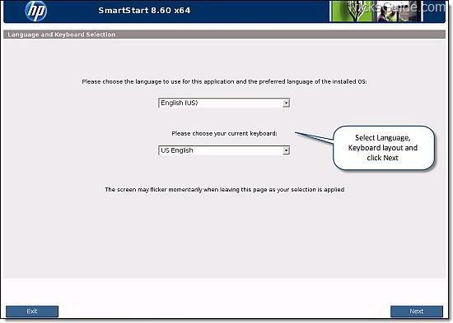4. Accept HP EULA by clicking Agree button (You have no choice here lol )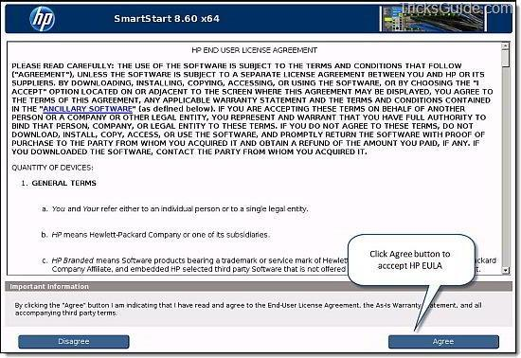5. Now you are the Home page of SmartStart CD (Check below provided screenshot)
6. Click on Maintenance button.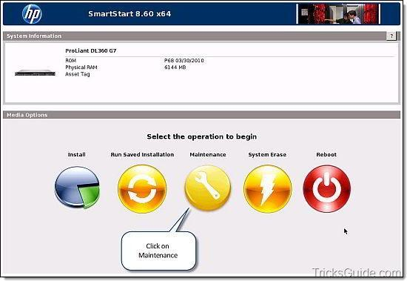7. Now you are at the Maintenance Options window (Check below provided screenshot)
8. Select HP Insight Diagnostics.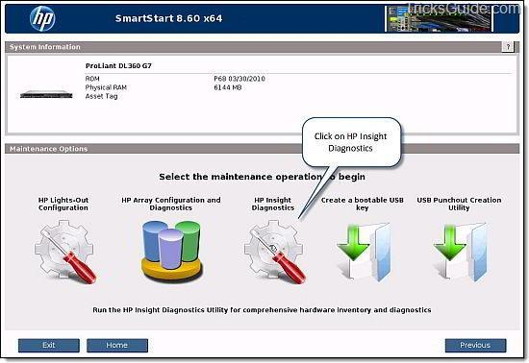9. HP Insight Diagnostics window will load and generate hardware report in a moment.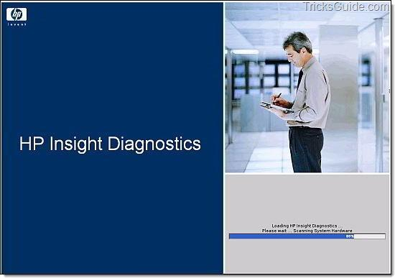10. Now you will be at the System Survey main page. It will show the consolidated report.
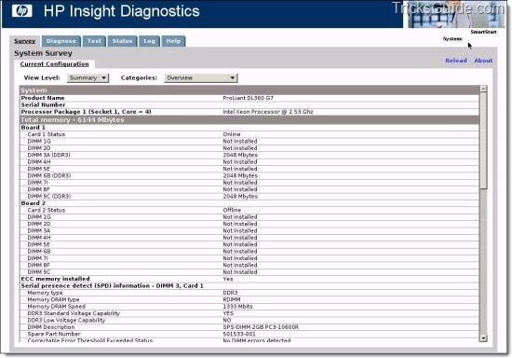
11. To generate Advanced System Survey report, Change the Categories drop down to All.
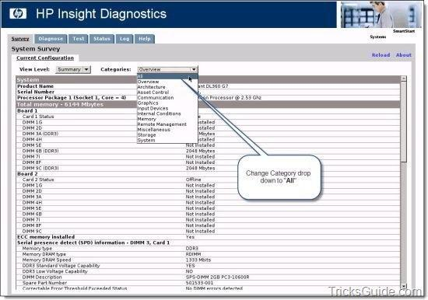
12. Then Change the View Level to Advanced(As shown below)
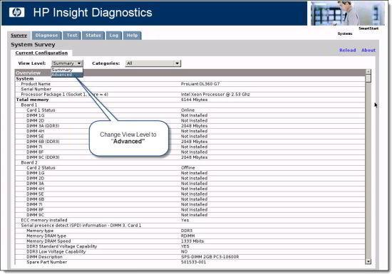13. Now what you see is the HP Advanced System Survey Report.
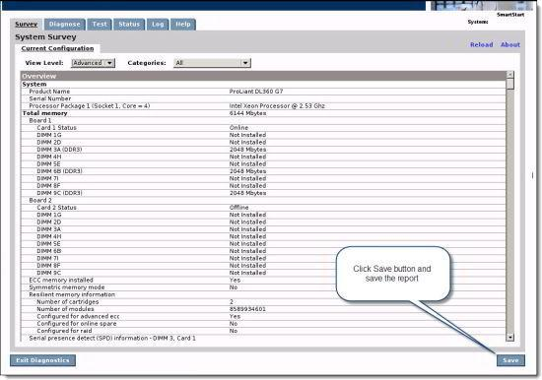14. Click Save button and save HP Advanced System Survey to a media (USB key etc)
15. Congrats!!

HP Advanced survey report is just a report which has all server information. If you wish to run diagnostics test on your server, please refer our guide which speaks about performing Offline Diagnostic test using HP SmartStart CD. You can find it here
- See more at: http://www.tricksguide.com/generate-advanced-survey-report-using-hp-smartstart-cd.html#sthash.nrAsSa28.dpuf

